KIDS ONLY

Hi Boys & Girls,

I’m glad you stopped by to visit my website. This project was created just for you!

You can check out all of my books at your school or local library. Write down my last name “SOENTPIET” and give it to the librarian and they will help you find my books.

What do you think of my books? I would love to hear from you. Please don’t be afraid to ask your teacher, librarian or parent for help in this project:
DIRECTIONS:

1) Print the form below. Hint, print the 2nd page on back of the 1st page.

2) Fold it in half so it will look like a 4-page booklet.

3) Complete the pages in the booklet.

- Mail your completed booklet and a self-addressed stamped envelope to me at:

CHRIS SOENTPIET
PO BOX 205
FLUSHING, NY 11358-1428

Discovering Chris Soentpiet – Book #3

Title:__________________________________
Author:________________________________
Publisher:___________________________________
Copyright date:______________________________

Book’s setting:____________________________
__________________________________________
Why is this book important?____________________
______________________________________________
What do I think of this book?:__________________
________________________________________________________________________________________________________________________________________________________
I would like to read this book to:_____________
_______________________________________
Why?__________________________________________________________________________
Reading and discovering Chris Soentpiet’s books:

www.soentpiet.com
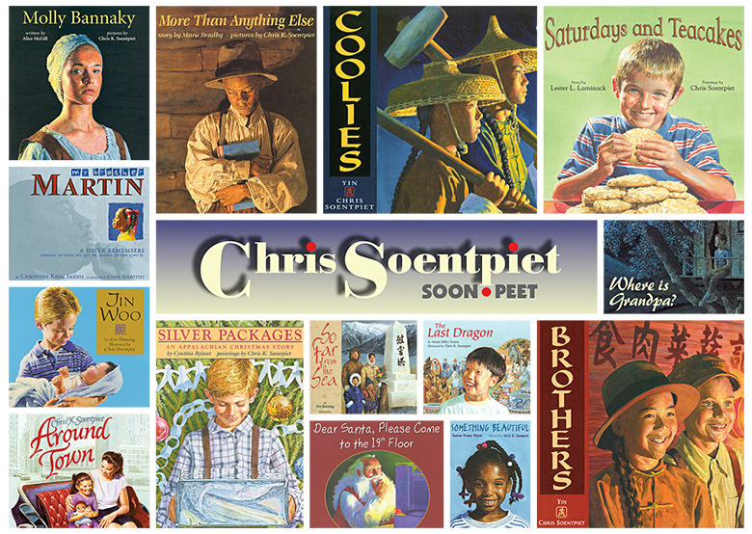To win a personalized autographed bookmark or postcard, your goal is to read 3 different books that were written or illustrated by Chris Soentpiet. After you read each book, complete and mail the pages in this booklet to: PO Box 205, Flushing, NY 11358
P.S. Don’t forget to ask your teacher or parent for help.

Print your name:___________________________
Your teacher’s name:____________________________
School name:________________________________
School Address:___________________________
City/State/Zip:_________________________________

Discovering Chris Soentpiet – Book #1

Title:___________________________________
Author:_________________________________
Publisher:__________________________________

Copyright date:______________________________
Book’s setting:____________________________
_______________________________________
Why is this book important?:______________________
_______________________________________
What do I think of this book?:_______________
____________________________________________________________________________________________________________________________________________________________
I would like to read this book to:_____________
_______________________________________
Why?__________________________________________________________________________

Discovering Chris Soentpiet – Book #2

Title:_____________________________________
Author:___________________________________
Publisher:________________________________
Copyright date:______________________________
Book’s setting:____________________________
_______________________________________
Why is this book important?______________________
_______________________________________
What do I think of this book?:_______________
_______________________________________
_____________________________________________________________________________________________________________________
I would like to read this book to:___________________
_____________________________________________
Why?________________________________________________________________________________________
__________________________________________

