Literacy in Motion Conference
Judson University
June, 2013
Using Chris Soentpiet’s Books
in the K – 3 Classroom
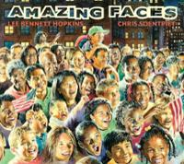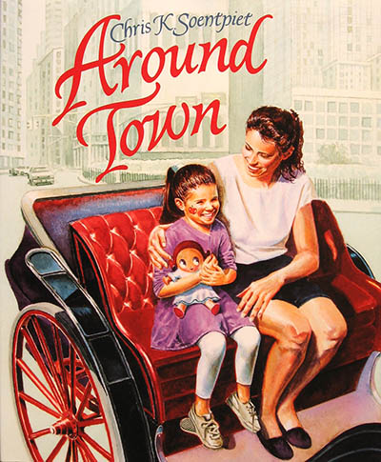

Presented by
Debbie Bernau and MarciaThompson
dbernau@sthubertschool.org marciathompson@u-46.org

Wonderings as We Unpacked Our Stack of Chris Soentpiet’s Books With Our Students:
*How will studying an illustrator and his illustrations help our children to think more deeply in order to grow as readers and as writers?
*How will each child picture our multicultural world differently, connect to history, and ultimately impact the world as a compassionate leader?
*How can these complex texts help us meet the new Common Core State Standards in our quest for all to be college and career ready? Can we provide more real world experiences inside our classroom walls?
*How will we put our professional reading into practice using these books as mentor texts?
*How will these titles (new to us) link to our other high-quality children’s books across the learning year and continue to expand our “whole room” classroom libraries?
Discoveries We Made Along the Way:
Reader’s Workshop -
*Reading the pictures/taking a picture walk/celebrating wordless picture books
*Pondering/pausing on the pictures to bring the words to life and form BIG ideas
*Sparking deepercomprehension conversations while reading aloud and with mini-lessons
*Linking our thinking to share with partners as we read – mini-lesson with a pair of flip flops - What do you think? Why do you think that? Tell me more. . .
*Connecting these books of different genres to other children’s books across the year
*Having these books available for independent reading/buddy reading
Writer’s Workshop -
*Becoming REAL illustrators of our words as authors ourselves
*Studying Chris Soentpiet’s style, process, and strategies as an artist – use of light, facial details, invisible triangles, color, and shape to be realistic
*Bringing Chris Soentpiet’s books alongside other favorite illustrators’ books across the year such as Lois Ehlert, Mo Willems, Eric Carle, and Jan Brett
*Including creative artist’s tools in our learning environments (writing center and/or art center) such as watercolors, colored pencils, markers, pens, pencils, washable paint and brushes, Do-A-Dots, multicultural crayon colors, rubber stamps, chalk, oil pastels, finger paint, collage materials, etc.
*Inviting friends to model as characters in our stories – developing our fine motor muscles while we make pictures look real with shapes, not just stick people – stocking math center with books about shapes - stocking art center with books about color and procedural texts about drawing*Observing real objects to illustrate for nonfiction writing – ex. diagram with labels*Having these books available to read like a writer/illustrator

A Few of Our Favorite Professional Books That Have Inspired Us:
Collins, K. (2004). Growing readers: Units of study in the primary classroom.Portland, ME: Stenhouse.
Culham, R., & Coutu, R. (2008). Using picture books to teach writing with the traits K-2. New York, NY: Scholastic.
DeMille, T. (2008). Making believe on paper: Fiction writing with young children. Portsmouth, NH: Heinemann.
Diller, D. (2003). Literacy work stations: making centers work. Portland, ME: Stenhouse.
Dorfman, L. R., & Cappelli, R. (2007). Mentor texts: Teaching writing through children’s literature, K-6. Portland, ME: Stenhouse.
Dorfman, L. R., & Cappelli, R. (2012). Poetry mentor texts: Making reading and writing connections, K-8. Portland, ME: Stenhouse.
Fuhler, C., & Walther, M. P. (2007). Literature is back!: Using the best books for teaching readers and writers across genres. New York, NY: Scholastic.
Gallagher, K. (2009). Readicide: How schools are killing reading and what you can do about it. Portland, ME: Stenhouse.
Gallagher, K. (2011). Write like this: Teaching real-world writing through modeling and mentor texts. Portland, ME: Stenhouse.
Heard, G., & McDonough, J. (2009). A place for wonder: Reading and writing nonfiction in the primary grades. Portland, ME: Stenhouse.
Layne, S. L. (2009).Igniting a passion for reading: Successful strategies for building lifetime readers. Portland, ME: Stenhouse.
Miller, D. (2013). Reading with meaning: Teaching comprehension in the primary grades(2nd ed.). Portland, ME: Stenhouse.
Miller, D. (2009). The book whisperer: Awakening the inner reader in every child. San Francisco, CA: Jossey-Bass.
Ray, K. W., & Cleaveland, L. B. (2004). About the authors: Writing workshop with our youngest writers. Portsmouth, NH: Heinemann.
Ray, K. W. (2010). In pictures and in words: Teaching the qualities of good writing through illustration study. Portsmouth, NH: Heinemann.
Routman, R. (2003). Reading essentials: The specifics you need to teach reading well.Portsmouth, NH: Heinemann.
Spandel, V. (2012). Creating young writers: Using the six traits to enrich writing process in primary classrooms. Boston, MA: Pearson.
Taberski, S. (2011). Comprehension from the ground up: Simplified, sensible instruction for the K-3 reading workshop. Portsmouth, NH: Heinemann.
Walther, M. P., & Fuhler, C. J. (2010). Teaching struggling readers with poetry. New York, NY: Scholastic.
Walther, M. P., & Phillips, K. A. (2012). Month-by-month reading instruction for the differentiated classroom (K-2). New York, NY: Scholastic.
Walther, M. P., & Phillips, K. A. (2009). Month-by-month trait-based writing instruction (K-2). New York, NY: Scholastic.
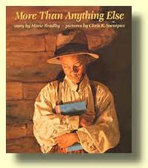
More Than Anything Else (Bradby, 1995)
“I think there is a secret in those books.”

Ideas from our Classrooms:
- A book to begin the year with in celebration of books and reading
- Hot read book stand – build interest in study of Chris Soentpiet’s illustrations - light
- Sign-in table question for younger students – Do you think this title is the best choice for this book?/Predicting activity for older students using reading response notebooks – What do you think the title has to do with the boy on the cover? What do you think he wants more than anything else?
- Name word work – our favorite words - class name chart for meaningful anchor chart alongside alphabet chart for linking letters and sounds, individual/group name puzzles – more name ideas - artwork/class books/acrostic poems/adjectives to describe person written on each letter of his/her name/ math activity comparing number of letters in names/technology – iPad or iPhone app for Fireworks Arcade to write name on screen by dragging finger through fireworks
- Using a thesaurus and dictionary with older students to find “new” words for writing
- Genre – historical fiction – compare Booker T. Washington’s life to children’s lives – learning to read at 9 years old, hungry for books
- Share reading life – Reading Star of the Week – develop awareness of what lifelong readers do – speaking and listening opportunity with presentations – book talks
- Awareness of others with less books/books as gifts/sharing books to build home libraries. . .
Family Literacy Night Book Swap/Ongoing Book Swap Drop Box

Children’s Books to Pair with this one:
Names –Chrysanthemum (Henkes, 1991), alphabet adventure (Wood & Wood, 2001), My Name is Yoon (Recorvits, 2003)
Books/Reading – Abe Lincoln: The Boy who Loved Books (Carpenter& Winters, 2006),Miss Moore Thought Otherwise: How Anne Carroll Moore Created Libraries for Children (Pinborough, 2013), Reading Makes You Feel Good (Parr, 2005), What Are You Doing? (Amado & Monroy, 2011), The Wonderful Book (Gore, 2010), We Are in a Book! (Willems, 2010), Five Little Monkeys reading in bed (Christelow, 2011), The Best Place to Read (Bertram & Bloom, 2003), I Am the Book (poems selected by Hopkins, 2011), Book Speak!: Poems About Books(Salas, 2011), Good Books, Good Times! (poems selected by Hopkins, 1990)
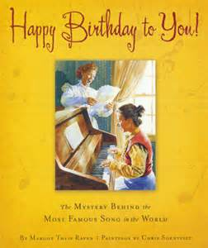
Happy Birthday to You!: The Mystery Behind the Most Famous Song in the World (Raven, 2008)

Ideas from our Classrooms:
• History of kindergarten • Music in the classroom with a songbook box of yearlong collection used for read aloud/sing aloud and then for self-selected reading choices/add play microphones for oral language/concepts about print, rhythm, rhyme, poetry picturebooks • Read like a writer to learn about writing songs/illustrate favorite songs/add new lyrics to old favorites
• Use patterns of simple songs like this one to create new tunes
• Notice what other authors do to piggyback off of other songs
- Have students write their personal versions of “Happy Birthday to You” and perform for classmates
• “Happy Birthday” song chart to use for birthdays with name cards
- Use Frog Street Press “Sing and Read” Color Little Books as pattern for learning sight words or sharing research of nonfiction facts!
- Use 6 Traits song charts when introducing writing traits to young learners, all sung to tunes of familiar songs (Culham, Scholastic Trait Crates K-3)
- Visit www.sleepingbearpress.com for downloadable teachers’ guides available
- Fun fact about Chris Soentpiet – He was a kindergarten teacher in New York City!

Children’s Books to Pair with this one:
take me out of the bathtub and other silly dilly songs (Katz, 2001), I’m still here in the bathtub: brand new silly dilly songs (Katz, 2003), Smelly Locker: silly dilly school songs (Katz, 2008)

Saturdays and Teacakes (Laminack, 2004)
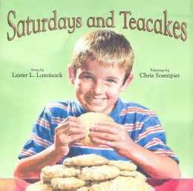
Ideas from our Classrooms:
- Mentor text for writing a personal narrative or memoir in journals, writer’s notebooks, or little books – bookmaking as modeled by Library Mouse (Kirk, 2007)
- Use of Alphaboxes chart to record favorite family memories from A to Z
- Opportunity for family storytelling with grandparents
- Opportunity to share own teacher’s memories of visits with grandparents through storytelling as a mini-lesson - how our talk leads to writing topics - narrowing a topic to go deeper but tell a lot through our written words and pictures - retelling with a beginning, middle, and end
- A book to combine with sharing summer memories, weekend plans, winter and spring breaks – writing to remember special events forever
- Sharing favorite family recipes – children writing in their own words or writing favorite family recipes with accompanying stories (Saturdays and Tamales, Saturdays and S’mores, Saturdays and Waffles)
- Annotate text with attention to what we notice and previously studied skills such as grammar skills, punctuation, and writer’s craft
- Make Mammaw Thompson’s recipe – informational text, recipe model of ingredients and directions, application of fractions and measurement in recipes
- Tea party, cookie exchange, or family literacy night to create all school recipe book of favorite family cookie recipes from different cultures to keep in school library – a first all school book authored by families with a new shelf made available in the school library for future all school books yet to be made
- Collect different cookbooks for children to enjoy reading in the kitchen
- Use days of the week to create new class version of Today is Monday song with other favorite foods
- Provide retelling props for early learners’ literacy in dramatic play centers such as a house kitchen, grocery store, or cafe

Children’s Books to Pair with this one:
The Relatives Came (Rylant, 1985), Today is Monday (Carle, 1993),Memoirs of a G0ldfish (Scillian, 2010), Memoirs of a Hamster (Scillian,2013), Cookies: Bite-Size Life Lessons (Rosenthal, 2006),Bunny Cakes (Wells, 1997), Cupcake (Harper, 2010), The Gingerbread Man Loose in the School (Murray, 2011), Who Took the Cookie from the Cookie Jar? (Garofoli, 2006), Mr. Cookie Baker (Wellington, 1992),The Duckling Gets a Cookie!? (Willems, 2012),The Doorbell Rang (Hutchins, 1986)

Jin Woo (Bunting, 2001)
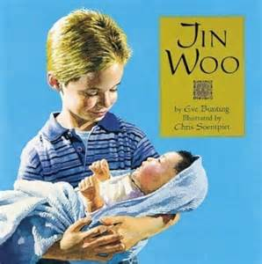
Ideas from our Classrooms:
- Adoption and new babies/Siblings – text-to-self connections
- Fun facts about Chris Soentpiet – He was adopted from South Korea. He is a husband and a dad.
- Family names and meanings/Bring in baby pictures to predict and share with all
- Write questions to interview family members about the day he/she came home
- “I thought of YOU!” and “Have I got a book for you!” – the perfect book for a new big brother or sister/notes available by classroom mailboxes to share books with friends – writing about reading, modeling and teaching students to begin to do this with others
- Compare to Love the Baby with a class Venn Diagram
Children’s Books to Pair with this one:
Love the Baby (Layne, 2007), Share with Brother (Layne, 2011), Stay with Sister (Layne, 2012), Little Pink Pup (Kerby, 2010), A Pocket Full of Kisses (Penn, 2006), The Name Jar (Choi, 2003),This Is the Baby(Fleming, 2004), Froggy’s Baby Sister (London, 2003), Time-Out for Sophie (Wells, 2013),Noisy Nora (Wells, 1994)
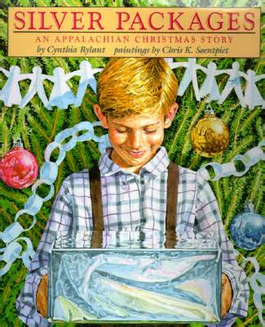
Silver Packages: An Appalachian Christmas Story (Rylant, 1997)

Ideas from our Classrooms:
- Human kindness – poverty – giving back to others – service projects such as collecting socks, mittens, baby blankets, or small toys – can send to “Christmas Train” organization or other community service agency
- Geography/map skills
- Needs vs. wants
- Author study of Cynthia Rylant – autobiography Best Wishes (Rylant, 1992) and biography Cynthia Rylant (Wheeler, 2009)
- Fun Fact about Chris Soentpiet – Cynthia Rylant is one of his favorite authors.
- Bring in a silver package gift box/bag to use for predicting of what students think book is about and what the silver package represents (hope) and/or put a play doctor’s kit inside to share with read aloud, and then ask students what would be their wishes for their own silver packages
- Compare toA Sign (Lyon, 1998) also illustrated by Chris Soentpiet to notice how the characters began as children and grew up to change the world
- Compare to Peacebound Trains (Balgassi, 1996) also illustrated by Chris Soentpiet to make text-to-text connections
- Compare to The Sparkle Box (Hardie, 2012) to partake in doing random acts of kindness for others
Children’s Books to Pair with this one:
The Gift of Nothing (McDonnell, 2005), The Polar Express (Van Allsburg, 1985), Freight Train (Crews, 1978),The Sparkle Box (Hardie, 2012), The Mitten Tree (Christiansen, 1995)
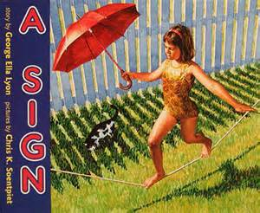

A Sign (Lyon, 1998)
“Now that I am grown I don’t bend glass tubes with fire like Leon Lasseter did but I try to make words glow. I don’t work the high wire fifty feet above your head. I put one word in front of the other here at my desk and hope the story won’t fall. And as for that rocket blasting out into space headed for the moon, it’s your heart I send these words to. They light the dark between us. A sign.”

Ideas from our Classrooms:
- Notice how this book is really about the author along her journey – notice how she brings voice to the page
- How do the words in her writing come to life through the illustrations of Chris Soentpiet? – glow, light
- Fun fact about Chris Soentpiet – He has a studio at home for his work.
- Invite community helper parents in to share about their jobs and how they decided to help others
- Students write and illustrate their own big someday dreams

Children’s Books to Pair with this one:
Me…Jane (McDonnell, 2011), Someday (Spinelli, 2007), ABC of JOBS: The people that make America work (Priddy, 2003), What Do You Want to Be? (Ellsworth, 2001), S is for Story: A Writer’s Alphabet (Hershenhorn, 2009)
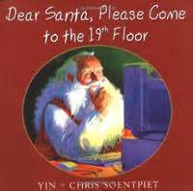

Dear Santa, Please Come to the 19th Floor (Yin, 2002)
“I lie down on my bed and minutes pass. I look out my window again, further down the street. I see someone in a red suit walking toward my building. It’s him!”

Ideas from our Classrooms:
- Note that author Yin is Chris Soentpiet’s wife – students can pair up with a friend to write little books or “hire” an illustrator
- Mentor text for letter writing
- Math – teen numbers
- Gifts of hope and believing and dreaming
- Awareness of special needs/wheelchairs/poverty/friendship/apartments/multicultural
- Compare to Silver Packages: An Appalachian Christmas Story (Rylant, 1997) also illustrated by Chris Soentpiet
- Compare to Around Town (Soentpiet, 1994) written and illustrated by Chris Soentpiet to experience city living
- Read like a writer/visualizing – “Like two peas in a pod.” “her curlers tight as springs,” “So I skip down the steps as fast as lightning.”
- Slow down to ponder on the double page spreads – What speech bubbles would you add to these illuminating illustrations?
- Study all of the fancy verbs to add to own writing using Alphaboxes chart to list for future writing
Children’s Books to Pair with this one:
The Polar Express (Van Allsburg,1985), holiday favorites
The Last Dragon (Nunes, 1995)
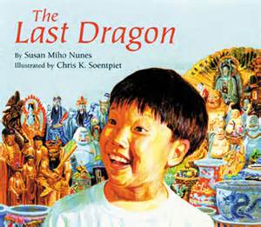

Ideas from our Classrooms:
- Big ideas – teamwork, unique contributions of others, problem-solving, never giving up, patience
- Fun Fact about Chris Soentpiet – This is his second book!
- Chinese culture - Chinese New Year, Chinatown, Chinese food
- Summer vacation – sharing about summer adventures – Summer Box project
- Kites – informational text
- Compare to Saturdays and Teacakes and Around Town also illustrated by Chris Soentpiet
- Notice how Chris Soentpiet creates the dragon to match the author’s words describing the dragon – glistened, glittering, glowed
- Describe and draw how the dragon changes from beginning to end with a reading strategy story sequence
- 3 new vocabulary words: admire, neighborhood, manners
- Procedural Text - explain/write steps in a process: how-to make a model airplane, how-to fly a kite, how-to make a duct-tape pen
Children’s Books to Pair with this one: Catch The Wind!: All About Kites (Gibbons, 1989),Summer Wonders (Raczka, 2009),Up North at the Cabin (Chall, 1992),Splat the Cat: Back to School, Splat (Scotton, 2011),The Crayon Box that Talked(DeRolf, 1997)
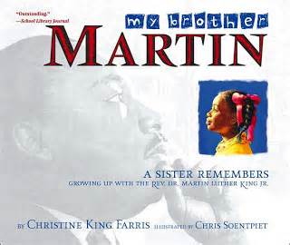

My Brother Martin (Farris, 2003)
Ideas from our Classrooms:
- Study as a writer – written by Dr. Martin Luther King Jr.’s sister with real photos and Chris Soentpiet’s realistic drawings – How might students use this mentor text to write about their siblings/family members? Ex. writing about going to brother’s baseball game or special memories or traditions
- Read other biographical texts about Dr. Martin Luther King Jr. to learn about his life and his impact on others/example of why picture books are for older students, too
- Previewing – a great book to model how to preview a book to students
- Opportunities for discussions on peace, equality, fairness, and dreams within classroom learning community
- Poetry – acrostic
- Flipchart – character analysis
- MLK quotes – memorize, illustrate, and respond to what quote means to you
- Hero traits chart - What makes a Hero?
- Hero unit – Hero study/research project
- Hero wax museum
- Abraham Lincoln Presidential Library and Museum, Springfield, IL - free resources online at www.PresidentLincoln.illinois.gov (IRC, 2013)

Children’s Books to Pair with this one:
Happy Birthday, Martin Luther King (Marzollo, 1993), Who Was Martin Luther King, Jr.? (Bader, 2007), What Was the March on Washington? (Krull, 2013), The Peace Book (Parr, 2004), A Rainbow of Friends: A Book to Celebrate Diversity (Hallinan, 1994), I Like BeingMe: Poems for Children About Feeling Special, Appreciating Others, and Getting Along (Lalli, 1997), Peaceful Pieces: Poems and Quilts About Peace (Hines, 2011), The Colors of Us (Katz, 1999), Shades of People (Rotner, 2009), All the Colors of the Earth (Hamanaka, 1994)
Series – DK Biography Series (DK Publishing), Time for Kids Biographies Series (Harper Collins), Young Patriot Series (Patria Press, Inc.), Who Was. . .? Series (Gosset & Dunlap)
www.readinga-z.com website used to pair other MLK books and for biography resources

Coolies (Yin, 2001)
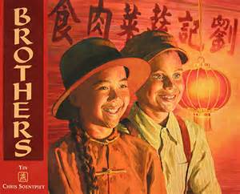
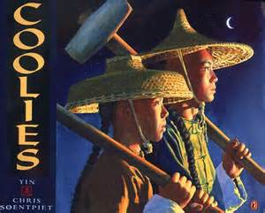
Sequel – Brothers (Yin, 2006)
Ideas from our Classrooms:
- Note that author Yin is Chris Soentpiet’s wife – another example of teaming up with a friend to be a writing team
- Provides an example of writing a sequel as an author
- Friendships – writing about special friends, adding details and more sentences with sticky dots details/sticky notes/writer’s notebooks
- Pen pals – letter writing to new friends in another school/state
- Written conversations – passing the paper back and forth
- Cultural awareness
- History – immigration
- Family

Children’s Books to Pair with these books:
Same, Same but Different (Kostecki-Shaw, 2011, Mail Myself to You (Guthrie, 1994),Yo! Yes? (Raschka, 1993), Horsefly and Honeybee(Cecil, 2012), This Plus That: Life’s Little Equations (Rosenthal, 2011), little blue and little yellow (Lionni, 1959)
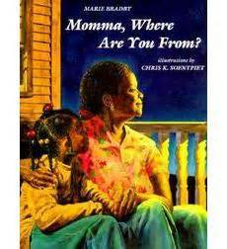

Momma, Where Are You From? (Bradby, 2000)
Ideas from our Classrooms:
- Family heritage – make a family tree, Family Heritage Wheel Project
- Neighborhood – create a map
- Storytelling with families for writing process
- Memories – recording them through our writing
- Bradby also wrote More Than Anything Else illustrated also by Chris Soentpiet
- Notice the use of light in illustrations – sunshine, children can try in little books
- Text-to-Text connections can be made to Saturdays and Teacakes , My Brother Martin,
Something Beautiful, America the Beautiful: Together We Stand, and Around Townalso illustrated by Chris Seontpiet

Children’s Books to Pair with this Book:
Family Tree (Martin, 2013), The Kids Family Tree Book (Leavitt, 2007),The Kissing Hand (Penn, 1993), The Kiss Box (Verburg, 2011),
Around Town (Soentpiet, 1994)
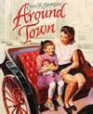
Ideas from our Classrooms:
- Community study – city/town, community helpers, transportation, map skills
- Chris Soentpiet’s first book – author and illustrator – Chris Soentpiet asked children he knew to model for this book – another chance to hire friends to draw for illustrations in little books
- Use of community rubber stamps – people, places, and vehicles with a stamp pad available for illustrating little books
- Drive little play car wheels through paint to design covers for little books – notice color mixing
- Read like a writer – mentor text pattern - writing with an opinion – “But some people live in the city and think it’s the best place of all.” But some people live in ________________ and think it’s the best place of all.” What makes your town/city the best place of all?
- Early learners’ block center as a VEHICLE for literacy and a STOP for books on the GO – see books below to match to reluctant readers
- Hunt for environmental print in book such as Subway –collect students’ environmental print of favorite places in community to write about where they would drive their cars to , collect environmental print all year long to attach to giant alphabet letters as a resource for linking letter sounds for writing and reading, attach environmental print to blocks in block center for buildings to recreate the town, collect words as a class from around town that start with blends ch, sh, and th for classroom linking charts (Cheetos, Chick-fil-A, Steak ‘n Shake, Goldfishcrackers, Wheat Thins, Jamba Juice smoothies, etc.)
- Write postcards from favorite locations
- Write a song to the tune of “Bingo” about your school’s town
- Create heart maps in writer’s notebooks like in My Map Book (Fanelli, 1995)
- Draw car diagrams for nonfiction text
- Make an acrostic of their town emphasizing special places they frequent “Around Town”
- Use atlas books to familiarize students with models of different maps
- Create map of their neighborhood/town/city making sure to label streets, important buildings and landmarks.
- Make a co-ordinate graph on grid paper labeling locations with symbols & ordered pairs, i.e. Butterfly Park 3,4 - St. Hubert School 6,8 – Police Station 4,5
Children’s Books to Pair with this Book:
Signs (Canizares & Chanko, 1999), I Read Signs (Hoban, 1983), My Map Book (Fanelli, 1995), Watch Me Go! (Young, 2009), On The Go (Morris, 1990), Let’s Look Inside the Red Car (Leslie, 1997), Cars: Rushing! Honking! Zooming! (Hubbell, 2006),My Car (Barton, 2001), Round Trip (Jonas, 1983), Let’s Go for a Drive! (Willems, 2012), Woody Guthrie’s Riding In My Car (Menchin, 2012), Five Little Monkeys wash the car (Christelow, 2000), Car Wash (Steen & Steen, 2001), City Colors (Milich, 2004), City 1 2 3 (Milich, 2005), The City ABC Book (Milich, 2001), Alphabet City (Johnson, 1995), Alphabeep: A Zipping, Zooming ABC (Pearson, 2003), Postcards from Chicago: Traveling with Anna (Crawford, 2008),Where Is the Sears Tower? (Mitchell, 2011), Pete the Cat: The Wheels on the Bus (Dean, 2013 – late June release), The Seals on the Bus (Hort, 2000), Don’t Let the Pigeon Drive the Bus! (Willems, 2003), How Will I Get to School This Year? (Pallotta, 2011), Where’s My T-R-U-C-K? (Beaumont, 2011), Goodnight, Goodnight, Construction Site (Rinker, 2011), My Friend Rabbit (Rohmann, 2002), Make Way For Ducklings (McCloskey, 1941), Knuffle Bunny (Willems, 2004), I Saw an Ant in a Parking Lot (Prince, 2007)
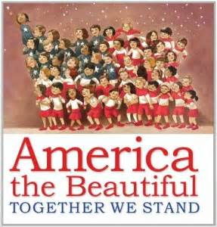

America the Beautiful: Together We Stand (Bates, 2013)
“We become not a melting pot but a beautiful mosaic.” – Jimmy Carter
Ideas from our Classrooms:
- World’s Fair Family Literacy Night – celebrate each family’s heritage throughout school – create houses to put around model of Earth using children’s handprints in green (land) and blue (water) paint
- Social Studies Musical Journey Through the States In conjunction with Fine Arts Teacher
- Reading response sheet for text to text, text to self, and text to world connections
- Informational text for presidents’ quotes, national landmarks, symbols, U.S. regions
- A collection of illustrators
- Useful for teaching previewing – even the jacket is a poster of all presidents
- Great for holidays and other calendar events – Memorial Day, 4th of July, Labor Day, Election Day, Veteran’s Day
- Children bring in sandwiches to share after pairing with The Sandwich Swap (Abdullah, 2010)
- Connect to Jin Woo, My Brother Martin, Momma, Where Are You From?, and Amazing Facesalso illustrated by Chris Soentpiet
- Investigate possibility of renting National Geographic Giant Traveling Map at www.nationalgeographic.com/giantmaps (IRA, 2013)

Children’s Books to Pair with this one:

The Sandwich Swap (Abdullah, 2010), I pledge allegiance (Martin & Sampson, 2002),
The Pledge of Allegiance (Scholastic, 2001), I Am America (Smith, 2003), To Be a Kid
(Ajmera & Ivanko, 1999), All the World (Scanlon, 2009), In My World (Ehlert, 2002), I Love You, Sun I Love You, Moon (Pandell, 1994), Thank you, World (McGinty, 2007), Me On The Map (Sweeney, 1996), My Global Address (Nunn, 1996), One Love (Marley, 2011), Library Mouse: A World to Explore (Kirk, 2010)

Amazing Faces (Hopkins, 2010)

Ideas from our Classrooms:

- Genre – poetry mentor text brimming with ideas for being poets in writer’s notebooks – patterns, lists, 2 verse, school connections, illustrating poems
- Beginning of year – getting to know amazing faces in class, create collage of classroom faces with goals and dreams written on speech bubbles
- Reading buddies (reading pairs – like a pair of flip flops) practice 2 verse poetry together, work on sight words, develop fluency together
- Come read on the park bench at Poetry Park - poetry celebrated in the classroom
- Fun fact about Chris Soentpiet – He has sketched in his sketch book/writer’s notebook on a park bench.

Children’s Books to Pair with this one:

Me I Am! (Prelutsky, 1983), You Read to Me, I’ll read to You books (Hoberman), Fancy Nancy Poet Extraordinaire (O’Connor, 2010), Falling Down The Page: A Book of List Poems (compiled by Heard, 2009), Messing Around on the Monkey Bars and other School Poems for Two Voices (Franco, 2009), Shout!: Little Poems that Roar, (Bagert, 2007), Morning, Noon, and Night: Poems to fill Your Day (selected by Taberski, 1996)
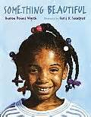

Something Beautiful (Wyeth, 1998)

“Beautiful! I think it means: something that when you have it, your heart is happy.”

Ideas from our Classrooms:

- Before reading, have students each bring in “something beautiful” in brown bags to share – What does beautiful mean to you?/After reading, share teacher bag with a mirror or book inside
- Step into the Story mini-lesson to connect to character(s) in story
- Fun fact about Chris Soentpiet – He has immersed himself in a story to become the characters as part of his research to provide the very best illustrations for the author.
- Notice writer’s notebook in front of book – go on spring walk (or other season) to write/sketch a Beautiful list of observations – take along mini magnifying glasses and pencils with writer’s notebooks – the power of wondering
- Support a local food pantry such as Food For Greater Elgin – Change for Hunger Challenge with area schools – learn more at FoodForGreaterElgin.org
- Pair fiction books with nonfiction books about taking care of Earth
- Plant tulip bulbs as yearlong project – predict what a bulb is, KWL chart,keep science journals of observations through the seasons, connect to little girl’s desire to plant flowers
- Another hero unit connection – how we all make the world a better place – it starts with us – change the world starting with our community - we can be anything we dream of – turning the bad to good – one person can make a difference–compassion – unforgettable life lessons for our students
- Connect to Silver Packages: An Appalachian Christmas Story and A Sign also illustrated by Chris Soentpiet
- Classroom learning environment – looking for GOOD , positive climate

Children’s Books to Pair with this one:

Blue Sky (Wood, 2012), May There always Be Sunshine (Gill, 2001), You Are My Sunshine (Church, 2011), and then it’s spring (Fogliano, 2012), Pete the Cat: I Love My White Shoes (Litwin, 2008), One of Those Days (Rosenthal, 2006), Have You Filled a Bucket Today?: A Guide to Daily Happiness for Kids (McCloud, 2006), Heartprints (Hallinan, 1999), exclamation mark (Rosenthal & Lichtenheld, 2013), Waiting for Wings (Ehlert, 2001), Amazing Grace (Hoffman, 1991), A Castle on Viola Street (Disalvo, 2001), My Garden (Henkes, 2010), Flower Garden (Bunting, 1994), Plant a Kiss (Rosenthal, 2012), The Gardener (Stewart, 1997), Sunflower House (Bunting, 1996), Plant A Little Seed (Christensen, 2012), Mrs. Spitzer’s Garden (Pattou, 2001), I Went Walking (Williams, 1989), Fancy Nancy Explorer Extraordinaire! (O’Connor, 2009), The World is Waiting for You (Kerley, 2013), Hands Can (Hudson, 2003), 26 Big Things Small Hands Do (Paratore, 2004), In the Tall, Tall Grass (Fleming, 1991), Kids For The Earth (Berger, 1994), Earth(Adamson, 2008), The Earth (Johnson, 2002), Hooray for You! (Richmond, 2001)

Other Picture Books for Older Readers also Illustrated by Chris Soentpiet

Where is Grandpa? (Barron, 2000) – just the fit for a grieving student
Peacebound Trains (Balgassi, 1996) – historical fiction – Korea
Molly Bannaky (McGill, 1999) – historical fiction – Benjamin Banneker
So Far from the Sea (Bunting, 1998) – historical fiction – WW2 – Pearl Harbor
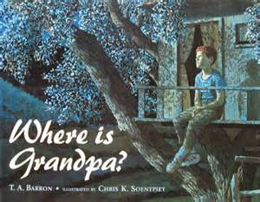
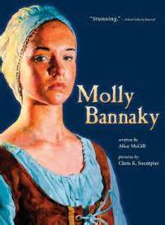
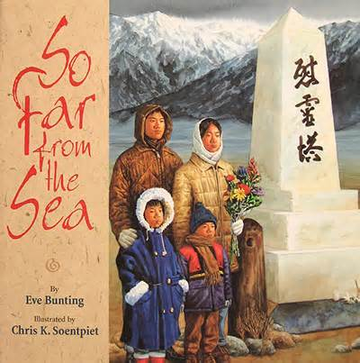

Additional Chris Soentpiet information available at www.soentpiet.com

